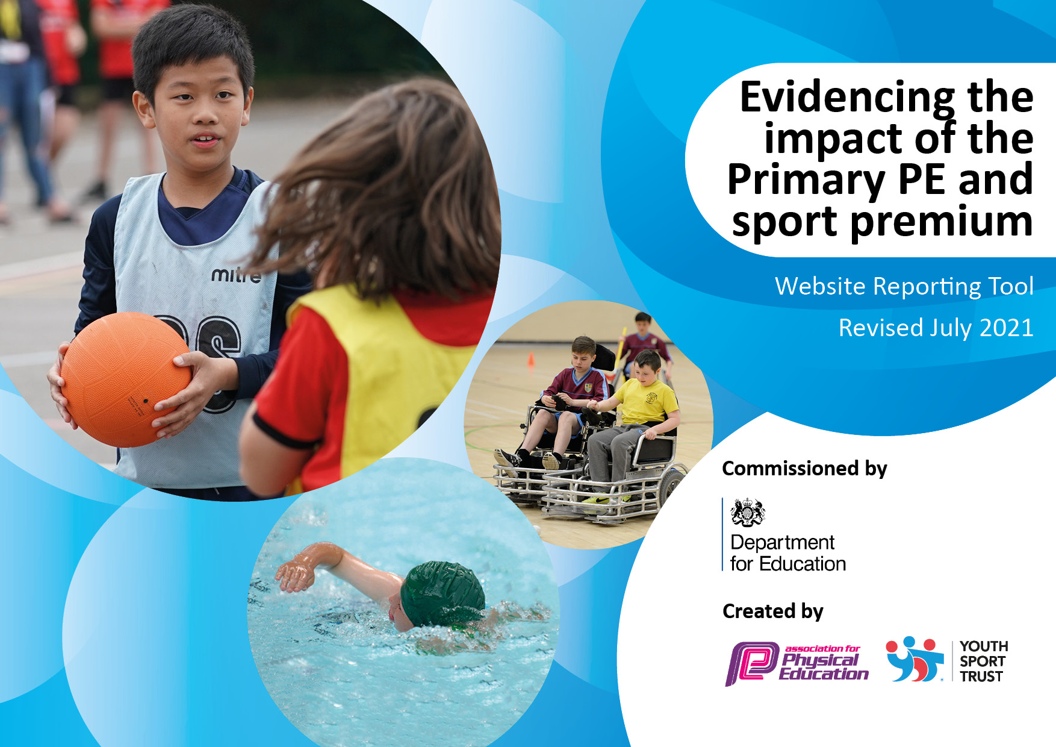
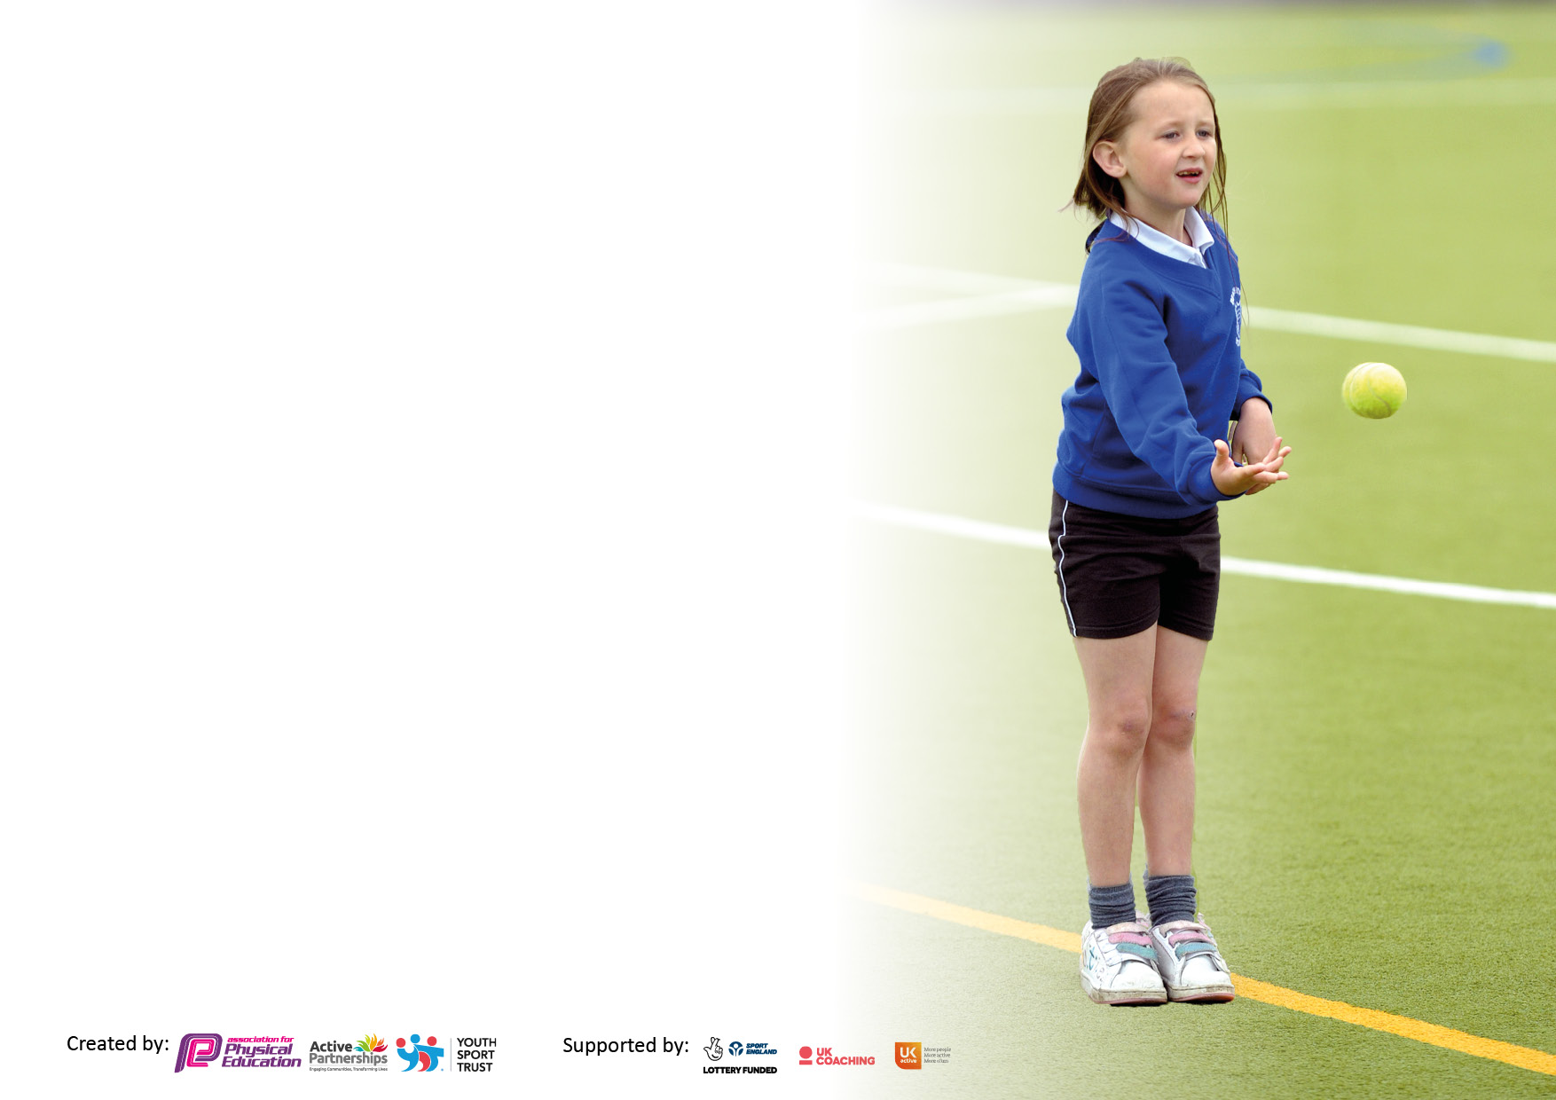

It is important that your grant is used effectively and based on school need. The Education Inspection Framework makes clear there will be a focus on ‘whether leaders and those responsible for governors all understand their respective roles and perform these in a way that enhances the effectiveness of the school’.

Under the Quality of Education Ofsted inspectors consider:
Intent - Curriculum design, coverage and appropriateness
Implementation - Curriculum delivery, Teaching (pedagogy) and Assessment
Impact - Attainment and progress

To assist schools with common transferable language this template has been developed to utilise the same three headings which should make your plans easily transferable between working documents.

Schools must use the funding to make additional and sustainable improvements to the quality of Physical Education, School Sport and Physical Activity (PESSPA) they offer. This means that you should use the Primary PE and sport premium to:

- Develop or add to the PESSPA activities that your school already offer
- Build capacity and capability within the school to ensure that improvements made now will benefit pupils joining the school in future years
- The Primary PE and sport premium should not be used to fund capital spend projects; the school’s budget should fund these.

Pleasevisitgov.ukfortherevisedDfEguidanceincludingthe5keyindicatorsacrosswhichschoolsshoulddemonstrate animprovement.Thisdocumentwillhelpyoutoreviewyourprovisionandtoreportyourspend.DfEencouragesschools to use this template as an effective way of meeting the reporting requirements of the Primary PE and sport premium.

We recommend you start by reflecting on the impact of current provision and reviewing the previous spend.

Schools are required to publish details of how they spend this funding, including any under-spend from 2019/2020, as well as on the impact it has on pupils’ PE and sport participation and attainment. All funding must be spent by 31st July 2022.

We recommend regularly updating the table and publishing it on your website throughout the year. This evidences your ongoing self-evaluation of how you are using the funding to secure maximum, sustainable impact. Final copy must be posted on your website by the end of the academic year and no later than the 31st July 2021. To see an example of how to complete the table please click HERE.
Created by: Supported by:

Details with regard to funding
Please complete the table below.

Total amount carried over from 2020/21 | £11,003
Total amount allocated for 2021/22 | £19,080
Total amount of funding for 2021/22. To be spent and reported on by 31st July 2022. | £30,083

Swimming Data
Please report on your Swimming Data below.

Meeting national curriculum requirements for swimming and water safety.

N.B. Complete this section to your best ability. For example you might have practised safe self-rescue techniques on dry land which you can then transfer to the pool when school swimming restarts.
Due to exceptional circumstances priority should be given to ensuring that pupils can perform safe self rescue even if they do not fully meet the first two requirements of the NC programme of study
What percentage of your current Year 6 cohort swim competently, confidently and proficiently over a distance of at least 25 metres?  N.B. Even though your pupils may swim in another year please report on their attainment on leaving primary school at the end of the summer term 2020.  Please see note above | 75.86%
What percentage of your current Year 6 cohort use a range of strokes effectively [for example, front crawl, backstroke and breaststroke]?  Please see note above | 79%
What percentage of your current Year 6 cohort perform safe self-rescue in different water-based situations? | 100%
Schools can choose to use the Primary PE and sport premium to provide additional provision for swimming but this must be for activity over and above the national curriculum requirements. Have you used it in this way? | Yes/No

Action Plan and Budget Tracking
Capture your intended annual spend against the 5 key indicators. Clarify the success criteria and evidence of impact that you intend to measure to evaluate for pupils today and for the future.

Academic Year: 2020/21 | Total fund allocated: | Date Updated:
Key indicator 1: The engagement of all pupils in regular physical activity – Chief Medical Officers guidelines recommend that primary school pupils undertake at least 30 minutes of physical activity a day in school |  |  |  | Percentage of total allocation:
 |  |  |  | 23%
Intent | Implementation |  | Impact
Your school focus should be clear what you want the pupils to know and be able to do and about  what they need to learn and to  consolidate through practice: | Make sure your actions to achieve are linked to your intentions: | Funding allocated: | Evidence of impact: what do pupils now know and what can they now do? What has changed?: | Sustainability and suggested next steps:
INTENT- We aim to provide 30 minutes of physical activity every day for all pupils, by providing time in the curriculum for daily mile runs and opportunities to be active at every playtime and lunchtime. The children have access to equipment during these sessions including the school trim trail, outdoor learning opportunities, equipment including high quality skipping ropes, elastics (and skipping workshops), access to football, basketball and netball games, table tennis tables, along with playground markings for hop scotch, daily mile track and dance and fitness opportunities.
Active playtimes and lunchtimes by providing equipment linked to skipping objectives  Curriculum ropes  Playground ropes lead by sports leaders (skipping workshops)  Every child to be given a skipping rope during their time at JC  Metal storage racks | Skipping workshop (2 days) coaching for all children F1-YR6 to provide skills to access skipping  KS1 and KS2 class sets of ropes  Playground sets KS1/KS2  Ongoing initiative ropes given to children new to school since 03/21 when we last gave out ropes  7 racks have been attached to the walls to allow easy storage and access to the ropes | £700  £599.99  £419.99  £414.95  £74.00 | Children have access to skipping sessions to raise the skipping profile in school, to encourage fitness training at playtimes and lunchtime. Curriculum sets if ropes available for KS1 and KS2 for warm-ups and basic skipping skills  % of children who can skip rose from 54% (AUT1)-86%(SUM2)  Ropes are stored neatly and children can access them easily | Ropes will remain available for children to access at all times including before and after school, playtimes and lunchtimes. Skipping has a high profile and both boys and girls access the ropes and have developed their fitness and tricks.
Daily mile track has been remarked when the playground was replaced. All classes run regularly and a timer will allow then to improve and check on their performance | Playground timer | £994.00 | This is yet to be installed, however running assessments will take place at the beginning of the Autumn Term to ascertain how far the children can run within a set time as a baseline, and then will be revisited at the end of the Summer Term to show progress. | This will continue without any additional budget being required
Active Playground Scheme facilitated by Sports leaders and midday supervisors | Equipment to promote 30 minutes of activity daily | £1,342.98 | The children have access to fitness equipment each playtime and lunchtime. Basketball, netball, table tennis, football, space hoppers, throwing and catching | Equipment will need replacing as wear and tear and a high percentage of the children accessing the equipment means that some equipment is damaged.
Outdoor learning kit as part of the Forest school provision which every child in school has access to. | Slack line kit | £33.32 | All classes have access to outdoor learning and can utilise the slack line kit to develop upper body strength | Ongoing resource
Storage boxes to provide quick and easy access to equipment used by sports leaders when running activities for children at playtime and lunchtimes. | 2 boxes for FS  2 large boxes for KS1 playground and KS2 playground | £171.48  £1,980 | Children need easy access to the equipment. The boxes need to be waterproof and able to withstand 400+ children accessing equipment. | Ongoing resource
Playleaders have been trained up in the previous academic year. They help to support lunchtime and playtime fitness and support at Sports days and other sporting events. | Playleaders requested hats and tabards so they could be easily identified by the other children | £139.99 | Playleaders work with all the children and are easy to spot. Children ask for support with playing games. | Next year’s sports-leaders will be trained up in AUT1 and will be able to reuse the equipment
Key indicator 2: The profile of PESSPA being raised across the school as a tool for whole school improvement |  |  |  | Percentage of total allocation:
 |  |  |  | 11%
Intent | Implementation |  | Impact
Your school focus should be clear what you want the pupils to know and be able to do and about  what they need to learn and to  consolidate through practice: | Make sure your actions to achieve are linked to your intentions: | Funding allocated: | Evidence of impact: what do pupils now know and what can they now do? What has changed? | Sustainability and suggested next steps:
INTENT-The profile of PESSPA is always reported on regularly at SDC committee meeting with the Governors as it is a standing agenda item. They receive a termly report on how the fund is being spent and the opportunities we are offering the staff and pupils (and hopefully the parents going forwards). The school website has a special section allocated to the PE and Sports funding which reports to parents and the community the ways we are promoting sport, fitness and mental well-being across the school. There are boards in school that show PE curriculum activities and the progression of skills from FS-YR6. When we compete as a school there is a display board showing team lists, photographs and a wall of honour showing children who access support outside of school at local and County level.
To promote a healthy lifestyle and to encourage the children to walk, scoot or ride to school during ‘Walk to School Week’ and going forwards | Hold a yearly walk to school challenge to raise the profile of walking to school and the health benefits of doing this. | £207 | Walk to school week was very successful with 92% of children choosing to walk, scoot or ride to school | Continue to hold a walk to school week each year to raise the health benefits of walking to school.
To provide access to the trim trail which has been out of action due to COVID restrictions. | To provide opportunities to develop upper body strength and coordination at lunchtimes and playtimes for the whole school. Need funds to make the trim trail safe and accessible to all children. | £940.27 | Number of children using the trim trail has increased by 100% and it has developed their skills | Continue to maintain the trim trail access for all pupils going forwards.
Issues relating to poor gross and fine motor skills have been identified by staff, as the children have returned from the Pandemic. This has had a huge impact on cutting, writing and basic pencil control. Research has also shown that the youngest children, have suffered the most, as their development of these skills has been halted during Covid, with many children missing out on stages of development. The FS have been struggling to address this and have requested a range of equipment to meet these needs. | We have ordered a range of equipment specifically for EYFS so that we can close this gap, allowing the children to keep up. This includes multi-sensory and emotion balls, climbing and crawling equipment, balance boards, stepping-stones and dance equipment. | £2,461.74 | Children have been using the equipment. New children will be baselined when they start school in AUT1 and will be assessed at the end of the year using a 12 point assessment, checking on fundamental ABC skills (Agility, Balancing and Coordination) | Ongoing assessment will track the development of these skills.

Key indicator 3: Increased confidence, knowledge and skills of all staff in teaching PE and sport |  |  |  | Percentage of total allocation:
 |  |  |  | 44%
Intent | Implementation |  | Impact
Your school focus should be clear | Make sure your actions to | Funding | Evidence of impact: what do | Sustainability and suggested
what you want the pupils to know | achieve are linked to your | allocated: | pupils now know and what | next steps:
and be able to do and about | intentions: |  | can they now do? What has
what they need to learn and to |  |  | changed?:
consolidate through practice:
INTENT-To provide top quality access to sessions with professional coaches both during curriculum time and after school club opportunities. This will benefit both the staff through CPD and pupils due to curriculum access to training.
To employ external and additional expert staff to run curriculum sessions side by side with staff members both as CPD opportunities and to provide opportunities for the children to develop their skills in areas identified as a weakness by staff | Develop throwing and catching skills, batting and bowling along with game tactics.  Gymnastics was identified as a weakness for staff pedagogy and all new staff have received training this year.  Fundamental skills have been identified as a weakness in FS due to children missing out on the development of these skills during the COVID lockdown | £9,488.40  See breakdown in box below | Basic skills have improved and this has been recorded on the school assessment system (PITA) Staff have noticed a marked improvement in gross motor skills especially throwing, catching and striking the ball. | Continue to develop these skills going forwards.
Continued CPD for staff including TAs in gymnastics, cricket and badminton/table tennis and fundamental skills | Cricket  Gymnastics  Badminton/table tennis/fundamental skills | £3,074.50  £3,863.96  £2,549.94 | YR5/YR3/YR2  YR1/YR5/YR1/FS  FS/YR5/YR4/YR3  All these children have received professional coaching from an outside facilitator | Staff have received training and are now able to teach the children the skills they have watched being delivered during CPD sessions. Staff are much more confident especially in the teaching of gymnastics and dance.
IMoves platform provides curriculum planning for all staff to use to ensure that sessions are well planned and that there is progression and assessments are available for staff to track the development of the children throughout their school life. | Staff use the planning and assessments to inform their judgements and pass this information onto the next teacher | £697 | Staff access good quality planning and resources, along with PITA (Place in time assessments) sheets to track the children’s development | Resources have already been used in previous years and some planning can be reused. Assessments are embedded into the half termly planning cycle.
Access to good quality PE equipment in curriculum time. Staff have access to class sets of footballs, netballs, basketballs, handballs and rugby balls in bags for easy access. Equipment includes goals, targets, rebounders, needles, stop watches, tape measures  Marker cones | Class sets of balls have been purchased to replace worn and flat balls. These are stored in the PE store and are easily accessible to the children. | £3212.14 | Observed PE sessions show more engagement by pupils as they are using good quality equipment and they can each access their own ball and staff are happy to have kit easily available for lessons. | Maintain equipment and ensure all balls are inflated regularly.
Key indicator 4: Broader experience of a range of sports and activities offered to all pupils |  |  |  | Percentage of total allocation:
 |  |  |  | 22%
 | Implementation |  | Impact
Your school focus should be clear | Make sure your actions to | Funding | Evidence of impact: what do | Sustainability and suggested
what you want the pupils to know | achieve are linked to your | allocated: | pupils now know and what | next steps:
and be able to do and about | intentions: |  | can they now do? What has
what they need to learn and to |  |  | changed?:
consolidate through practice:
INTENT-The school focus is to provide a wide range of activities and experiences for the children, above and beyond the curriculum offer. We intend that every child leaving John Clifford will be able to complete the JC triathlon in that they will be able to swim 25m, run a mile and be able to ride a bike safely (on the road)
We also run a sports academy for 1 term for the YR3/4/5 children where they can access coaching and sports outside the school curriculum including archery, badminton, table tennis and cross country running.
Additional achievements:  Archery being taught  Badminton after school club  Skipping days  Sports week  Rounders after school club  Dance festival  Sports days | Provide a range of opportunities for the children throughout the school year | £26.50 Egg and spoon set for sports day | All YR3 children had an opportunity to have a go at archery during their Sports Academy sessions.  YR6 after school badminton club  YR3/4 had badminton taster sessions  YR3 after school rounders club  YR1/2 children accessed dance sessions and performed at the Family of Schools Dance Festival | Staff have received support and training to run these sessions and they will be able to repeat these opportunities going forward.
YR6 Top up swimming curriculum to ensure that all children have the additional opportunity (we offer 4 terms of swimming lessons in YR4 & 5 | Children attend top-up swimming sessions at the Olympic sized pool at the Harvey Haddon sports Village (6 weeks SUM2) | £1,040 | See % of children achieving the National curriculum requirements for swimming and water safety. | If possible, continue this support for YR6 pupils as due to many different reasons many of our children do not access swimming at home.
Bike ability opportunities in YR5  YR3/4 to assess their children to find out which are unable to ride a bike. They will then be able to access bike sessions during the school day to enable them to ride using our supply of 15 bikes and helmets. | All YR5 children take part in the Bike Ability scheme in SPR2, with an additional top up opportunity in the SUM2 term | Free at present | 89% of children who are able to ride a bike at the end of YR5  50 children completed Level 1  47 children completed Level 2  School provided bikes for those children who did not have access to them. | If possible, continue this support for YR5 pupils as due to many different reasons many of our children do not access bike riding at home.
Provide bikes at FS to allow children to access and learn how to ride a bike. We have several balance bikes but we have supplemented this with scooters and bikes | FS children have the opportunity to start learning how to ride a bike and develop the balance skills. | £666.95 | Assessments will begin in AUT1 to assess those children who need additional support to develop their balance and ability to be ready to ride a bike. Children in YR3/4 to be assessed on bikes before they do ‘Bike-ability’ in YR5 | Maintain equipment going forward, as we have several staff members who are keen to maintain and service bikes.
Equipment to support SEND children to develop basic skills and develop confidence and access to different activities | Outside coordinator supported SEND children and those identified with poor eye hand coordination to play boccia, goal ball and Kurling. | £505  (Boccia, goalball and Kurling set) | Marked improvement in these children’s gross and fine motor skills, as well as better teamwork. | Plans to enter SEND festivals going forward and Boccia club being set up by a member of staff at lunchtimes.
Badminton provision. This is a new sport at JC and we have been running CPD curriculum sessions as well as after school opportunities for a range of the older children. | Sessions have been run across KS2 for children as part of the sports academy and after school provision. A class kit has been purchased as we have been borrowing equipment from facilitator | £460.98 | Over 120 children have had a chance at having badminton lessons in curriculum time, staff have received CPD and an after school club for YR6 has introduced them to the sport before they go to secondary school | Equipment and training means that badminton can be confidently taught in school and will become part of the ‘Sports Academy’ offer going forwards.
Hockey provision has been introduced as the children identified a wish to learn the game again in the Sports Academy | Equipment has been purchased and hockey was taught in the YR3 Sports Academy | £155.97 | 60 children received a taster session and 15 children received intensive teaching as part of the YR3 Sports Academy. | Equipment is available going forward.
Maypole dancing manual | Maypole and Country dancing is part of the YR2 curriculum. Further CPD was required to extend this offer. | Maypole Manual £37.00 | All YR2 children had access to Maypole dancing and some children participated in a Summer Festival to showcase for parents. | Maypole dancing will continue to be taught at an improved level due to CPD
2 boom boxes have been provided to support with outdoor country dancing and for sports day announcements. One is allocated to FS/KS1 and the other in KS2 | Outdoor and indoor music is available at all times. The microphone is used at sporting events throughout the year | £300 | Children can access country dancing and Maypole dancing as well as skipping music for outdoor PE and a PA system | Ongoing
Tennis provision- We have been developing links with the Nottingham Tennis Centre and two members of staff have completed their teacher training award. The two YR6 classes also attended the Nottingham Open and received training and the opportunity to watch top quality players | To upgrade and replace old equipment, including balls, nets and rackets. | £563  Nets and Balls | Tennis curriculum teaching has improved as equipment is of a higher standard and the profile of tennis has risen amongst the pupils | Tennis is taught throughout the school by a member of staff who has completed the LTA training
Archery was introduced last year and was so successful and very popular with the children that it was decided that we should purchase another set to allow more children to participate. | To provide an addition set of bows and arrows to further develop the sport | £524.99 | 180 YR3/4/5 children were able to access archery as part of their Sports Academy provision. | Will continue to develop the sport and more children will be able to access it
Indoor and outdoor table tennis provision | Indoor and outdoor tables were purchased in previous years, new equipment was needed to replace old and broken equipment. | £109.00 | Children have access to table tennis at playtime and lunchtime, as well as curriculum offer and after school clubs. | Ongoing
Rounders equipment | These have not been updated in the last 30 years and have started to crack and become dangerous | £105.00 | Safe equipment has been used by the children. | Ongoing
After-school clubs have been set up for all children across the school to access | YR1/2/3/5/6 gymnastics  YR3/4/5/6 cricket  YR6 badminton  YR1/2 Basic fundamental skills | £2,000 | All year groups have been offered been opportunity to access free after school clubs in SPR1/SPR2/SUM1/SUM2  There were no clubs in AUT1/AUT2 due to Covid restrictions

Key indicator 5: Increased participation in competitive sport |  |  |  | Percentage of total allocation:
 |  |  |  | 0%
Intent | Implementation |  | Impact
Your school focus should be clear | Make sure your actions to | Funding | Evidence of impact: what do | Sustainability and suggested
what you want the pupils to know | achieve are linked to your | allocated: | pupils now know and what | next steps:
and be able to do and about | intentions: |  | can they now do? What has
what they need to learn and to |  |  | changed?:
consolidate through practice:
INTENT-There have been severe restrictions this year in the amount of inter and intra school sport due to COVID regulations. Football, netball and running coaching have been available and have led to the development of a bank of players who can represent the school in these sports going forwards. The school was working in class bubbles and YR groups were not allowed to interact until SPR2.
To provide opportunities to allow children to participate in competitive sports | Release staff to coach the netball and football teams and provide a coach to train the cross country runners |  | Netball team have played in three tournaments. | These opportunities should increase in the next academic year as restrictions are relaxed after COVID

Signed off by
Head Teacher: | Janine Waring
Date: | 28.07.22
Subject Leader: | Carol Bamford
Date: | 28.07.22
Governor: | Simon Hogg
Date: | 28.07.22

